Blythe Elementary School

2nd Grade

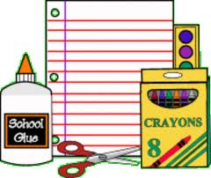

Supply List

2024-2025

* **6 –spiral notebooks**
* **12 (or more) #2 pencils**
* **1 box of 24 crayons**
* **1 pair of school scissors**
* **1 glue stick**
* **1 bottle school glue**
* **2 pkg. of 100 white index cards**
* **1 pkg. wide ruled notebook paper**
* **Pair of headphones or earbuds (Place earbuds in a Ziploc bag labeled with student’s name)**

***Teacher’s Wish List***

* **1 pack of copy paper**
* **1 Large bottle hand sanitizer**
* **4 boxes Kleenex tissue**
* **Dry erase markers**
* **Ziploc type bags (snack, quart, and gallon sizes)**

**\*Please label all items with your child’s name before bringing them to school.**

**We will also need household items throughout the year, such as paper towel tubes, shoe boxes, and empty plastic containers for projects.**